OPERATION & MAINTENANCE OF MAIN ENGINE & CONTROL DEVICE

The main engine is to be operated strictly in accordance with the maker’s instruction book.

Generally, under normal conditions, the main engine should always be operated at a speed equivalent to 85% of MCR as power and not to exceed Thermal Limit Line of maker’s recommended Load Diagram.

In some cases, C/P requires speed equivalent to 90% of MCR which should be complied with.

If, however, the Charterers requests for slow steaming (MEP Running), lower than the company specified minimum limit for running Main Engine at 50% of MCR, such may be done in consultation with the PIC.

To clear accumulated soot during such slow steaming, frequency of soot blow of the exhaust gas economizer is to be increased to more than usual in consultation with PIC.

The maintenance of various components of the main engine is to be carried out as per the procedures and interval given in the maker’s instruction book and the company’s PMS.

For each single voyage, the typical main engine performance data is required to be taken down in detail on the form Main Engine Performance Data – (formE45)

Under normal conditions, this report (two reports for round-trip voyage ballast & loaded) is required to be sent to company by the end of the current round-trip voyage.

However, when engine trouble or any abnormalities are found, these reports are required to be taken and sent to company as soon as possible for analysis and for advice from the technical department.

Running hours of the important parts of the main engine are required to be calculated and reported to company once every (3) three months, by using the form of Main Part Running Hours Report (E68).

This information allows company to plan a short-term maintenance schedule, including the schedule of when and where to conduct necessary overhauling and to prepare spare parts.

When an overhauling is carried out, the wear down on cylinder liners, piston ring grooves, and piston rings, etc., must be calibrated and recorded using the form of Main Engine Overhaul Report (E42).

The control equipment, such as the governor, maneuvering relay, linkage, etc. including the safety devices, is to be checked thoroughly.

The 1st engineer is responsible for implementing the maintenance work for the main engine and its control equipment.

The engineer in charge shall take the necessary data for machinery such as revolutions, temperature, pressure, oil quantity and so on at regular times during every duty watch-keeping while at sea and shall make an effort to maintain the good working condition of each part and enter a record of them in the engine logbook every day.

The chief engineer is to check the content of the report by himself, especially obtained values of speed and fuel oil consumption in the LOG and other reports.

The 1st engineer shall take indicator cards once for each laden/ballast voyage to calculate an output/ F.O. consumption of M/Engine and try to maintain good working conditions.

In the meantime, as for the engine without indicator cams, the calculation method shall be followed by the maker’s instructions.

The 1st engineer shall measure the R.O.B. of L.O. at the time of entering a port and shall calculate the consumption of cylinder oil/system oil for each voyage and shall also record them in the separately prepared Monthly L.O.

Inventory (ERP-05-09 B) with a copy being kept by the ship and another being submitted to company at the end of month.

He shall confirm whether the consumption is proper or not and make reference for the supply amount of L.O.

The system oil shall always be treated by circulated purification at sea and shall also be kept in good condition by the manufacturer’s analysis to justify with a sample, which is sent by the vessel once every 6 months.

The 1st engineer officer shall obtain the sealing condition of each stuffing box of the cylinders by measuring the oil leakage once every 3 months and to decide their overhaul time.

When the following items are overhauled and checked, obtained data shall be recorded in the separately prepared recording paper:

The exhaust valve:

To realize the limit of use by implementing measurements and maintenance

The fuel valve:

To maintain the specified injection pressure and to keep a good burning condition.

The piston:

To check and measure the burn away (heat damage) of the piston crown, existence of the cracks, wear and tear of the rings, ring grooves and liners and to confirm the burning condition;

If necessary, to study the change of cylinder oil supply amount and time of overhaul, etc.

Stuffing box:

To measure the wear and tear of the rings (use the piston ring measurement form) and to confirm the abrasive surface condition of the piston rods.

Crank deflection:

To confirm the value of deflection is being within an adjustable limit.

In principle, to measure the deflection whenever there is no draft change of the vessel and to check the crankcase is down at the same time.

Smoke Condition to be checked.

On LNG vessels:

the gas is supplied to the Main and Aux Engines by means of “Double Walled” pipes for safety.

Several gas detectors are fitted on these pipes. The GVU (Gas Valve Units) regulate the flow of gas, monitor the leakages, and stop gas flow as required.

GVU outlet vents lead to outside E/R.

Preventive measures against Scuffing accidents of ME liner and Piston ring while using VLSFO:

    - Since the start of using VLSFO after inception of IMO fuel regulations in 2020, accidents with ME liner and piston have occurred frequently.
    - It is a situation where it is difficult for the whole industry and identifying the cause even after investigating is proving difficult, however it is strongly suspected that the VLSFO itself is undoubtedly one of the causes.
    - On the other hand, there may be a compatibility problem between low-BN and various VLSFOs.
    - Various organizations have been investigating the causes so far, but unfortunately no clear conclusion has been reached yet.
    - Therefore, it is also true that effective countermeasures cannot be formulated.
    - In view of the above, the most important thing that can be done at the moment is to identify abnormal signs as early as possible. (Vessel is required to take responsive action based on early signs according to the actual situation.)

Following countermeasures have been considered and vessels are required to immediately implement them:

SDA (Scavenge Drain analysis) On board Test Kid selection and supply:

It is essential that the method of use is simple.

The measurement items are iron contained in the drain.

Please consult with the SI in charge if vessel do not have a Test Kit.

Establishment of Data Monitoring procedure such as measurement timing and interval by SDA test:

UEC engine scavenging chamber drain piping is common.

Drain cannot be collected from each unit.

In that case, please consult with the SI in charge and plan a modification so that samples can be taken from each unit.

Also, in case to modify, it will be needed to consult engine maker for internal modification.

Establishment of operational Data Monitoring procedure for early identification of Scuffing signs during operation:

Establishment of Data Mentoring Sheet/ Daily Data.

It is like an engine operation record book.

Increased frequency of scavenge port inspection and improved accuracy of inspection results.

Strengthen cooperation with engine maker by using the above Monitoring system and so on.

Specific implementation policy.

Please check the contents and instructions of each form carefully and strictly comply as per the guidelines/Indication mentioned in the forms:

(y) Propeller shaft condition monitoring (PSCM):

- Where applicable ships specific documents to be prepared as per classification society requirements.
- These documents to be updated on daily and monthly basis. Lube oil sample of stern tube lube oil system to be sent to designated laboratory at 6 months interval.
- Lube oil analysis report along with all the records pertaining to PSCM for this duration should be submitted to the classification society to maintain PSCM notation.

(z) Frequency of Main Engine Cooling water test

- ME Cooling water is to be tested and checked every three days and the results to be reported to company once a month, using the form of E41 Cooling water analysis report.

- Testing of Cooling water by a shore technician is to be carried out once every 6 months.

4.5.1 Immobilization of Main Engines

Main Engine immobilization should not be carried out without permission from the port authorities while vessel is within port limits.

Outside port limits vessel may immobilize the Main Engine as necessary to carry out maintenance and / or repairs.

Such stoppage should be informed to the respective PIC.

A risk assessment should be carried out for the stoppage, including, but not limited to the following factors.

- The presence of the navigational hazards in the close proximity and the traffic density in the area.
- The weather (wind, current, swell, drift, etc.) at the time of stoppage and during the entire period of immobilization.
- Taking expected workload into account, to plan crew rotation and rest.
- The proximity of piracy prone area or high-risk piracy area.
- Proper PPE for the job and good understanding of the job to be carried out.
- Work planning and requirements of resources like spares and tools.

- Proper Interdepartmental communication and coordination.
- Coordination and communication with the PIC for the stoppage, including the duration of planned stoppage.
- The use of lights shapes and sound signals, as may be applicable.

On LNG vessels fitted with two Engines:
- In case required, only one engine can be used after due consultation with the PIC and / or Charterers.
- In such cases the stationary engine shaft is to be positively locked by the shaft locking arrangement provided for the purpose (not by Turning Gear).
- The shaft power, vibration, Stern Tubes, Steering Gear, Rudder’s mush be checked for overloading or abnormal condition.

Instruction for Filling Form E42& E43

Cylinder Liner Measuring Procedure.

4.5.2.1 Adjusting Procedure of Bore Gauge.

Set the Bore gauge on the Standard Gauge plate provided by the maker.

Turn and adjust as Inner scale indicates to “3”.

Fix one end of the micrometer in the standard gauge and swing the free end slightly in the forward/Backward direction and up/down directions.

Confirm that the outer scale moves in the negative directions when swung in the Forward/Backward direction and moves in the positive directions when swung in up and down directions.

After confirmation, set the outer scale to “Zero.”

If standard gauge dimension is 500.08, outer scale to be turned “8” to negative/minus direction.

Remove Bore gauge from the Standard gauge, the vernier/outer scale must return to “Zero.”

This completes the adjustment procedure and now gauge is ready for measurement. (Do not change this adjustment, if it gets changed, please carry out the steps a to e again.)

Measuring Procedure.

Before taking measurements, please ensure that the gauge and the cylinder liner temperature are similar.

Insert the Bore gauge into the Cylinder liner.

One end the bore gauge fixed to the position plate.

Swing other end forward and backward direction slightly.

And get most positive/plus reading, and then do not move forward and backward direction.

Wing the bore gauge in up and down direction.

And get Max negative/minus reading. This is the actual wear down value.

Also confirm the point the Inner pointer shows.

If Inner pointer shows.

Between 3-2: Wear down shows directly Max negative/minus Reading.

Between 2-1: Wear down shows Max negative/minus reading + 1mm.

Between 1-0: Wear down shows Max negative/minus reading + 2mm.

Note:

- In case the dial gauge dose not move, it is shows that the wear value exceeds the limit of 3.0mm.
- In above case to be adjusted and put the Vernier/inner scale at position “4”.

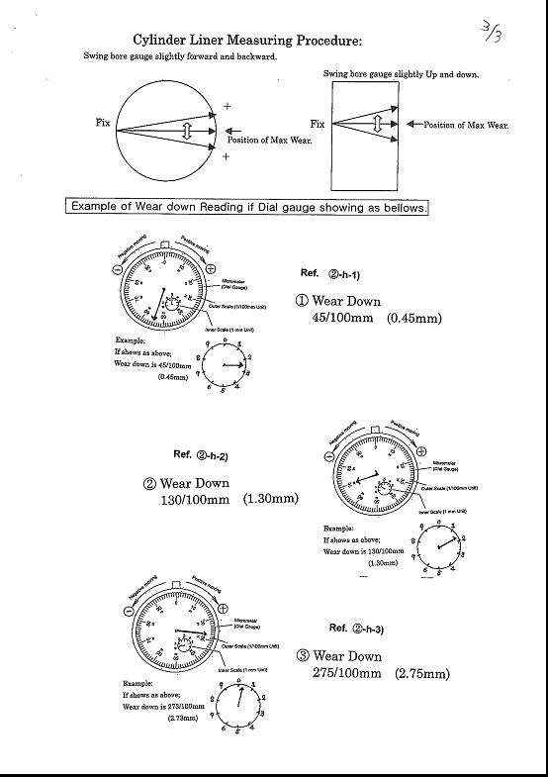

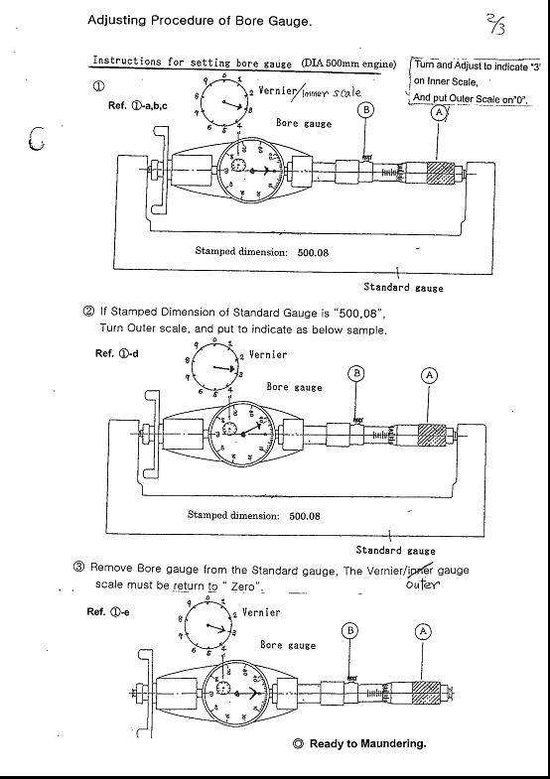

4.5.3 Instructions for Filling Form E-39

Procedure for taking Photos of Piston Ring and Liner Running Surface while scavenge port inspection.

When ME scavenge port, inspection is carried out as per Check List ERP-03-14H, the appropriate Photo is very useful to know actual conditions.

So that we will advise to you how to take pictures, The Photo taking procedure is mentioned below.

Preparation works.

Opening the scavenging trunk or Inspection Covers.

Preparing the following items.

- Air Fan for supplying the fresh air to scavenging trunk inside.
- Flashlight, turning gear remote controller, Boots or shoes cover.
- Marker pen (light colour)
- Rags with bucket.

4.5.4 Setting the piston position.

Set the piston position so that all (four) piston rings running surface and top land (piston land above top ring) can be seen from scavenging port.

Wiping up the piston ring running surface and liner outside surface.

Wipe up the cylinder liner surfaces. (Refer to the Fig, 1)

Wipe up the dirt from scavenging port inside and liner outside surface for four scavenging ports by rags.

Wipe up the dirty oil from the piston ring running surfaces for four scavenging ports by rags.

Mark the cylinder No. On the 3rd ring land which between 2nd and 3rd piston ring.

4.5.4.2 Taking photos (Refer to sample photos Fig.2)

Piston Ring.

- For ring package photo, take two photos for one view with changing observation angle (view from upper and lower angles). Without halation.
- For close-up photos (Top & 2nd, 3rd & 4 ring), Take the two photos for one view with changing observation angle. (View from upper and lower angles), without halation for three or four scavenging ports.

Piston top land

Take one photo after piston setting by turning.

Piston top surface.

Take photos by inserting the camera from scavenging port.

Cylinder liner running surface.

Take photos by inserting the camera from scavenging port.

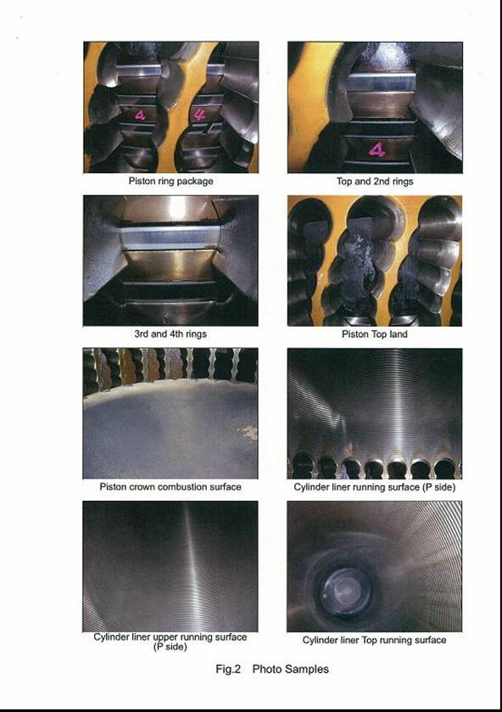

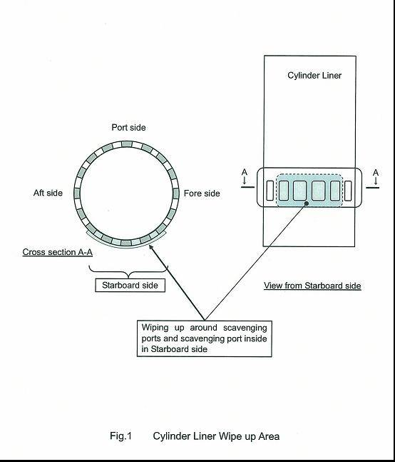

-x-

